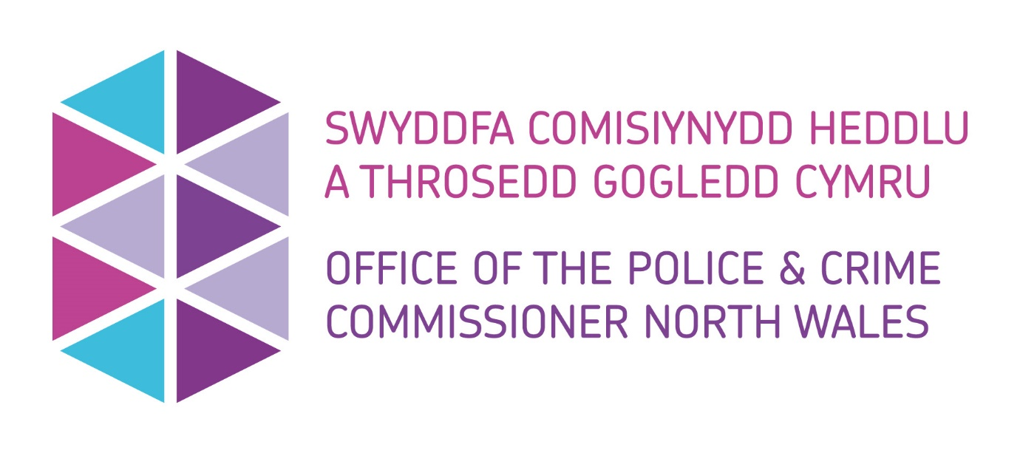

Application for Small Grant Funding
Police and Crime Commissioner for North Wales

Introduction
Police & Crime Commissioners across the UK have the discretion of awarding funding to various groups by exercising of the power conferred by section 143 of the Anti-social Behaviour, Crime and Policing Act 2014.
North Wales Police & Crime Commissioner has the authority to exercise this power to support his Police and Crime Plan and ensure the key priorities are met.
North Wales Police & Crime Commissioner has funding available to communities, partners, and charities through various grants and/or donations.

Using this form
Please use this form if you would like to apply for a maximum of £10,000.00 from the Police and Crime Commissioner.

Accessibility
If it is difficult for you to use this form or this service, for example, if English is not your first language or you have a disability, then please contact us using the details provided below:
Telephone: 01492 805486
Email: Commissioning@northwales.police.uk
If you require any adjustments to support you to complete this application form, please let us know. For example, if you have a visual impairment, you may require written responses in larger text.

What happens to the information in the application form?
The information you provide will be entered into our systems.
If you require further information about how your data will be handled, please call us on 01492 805486.
For information about how we handle your personal information, please read our privacy policy at:
Privacy Policy | Office of the Police and Crime Commissioner North Wales (northwales-pcc.gov.uk)

Where to send this form:
Please submit your completed form to the Office of the Police and Crime Commissioner (OPCC), as below:
Email: Commissioning@northwales.police.uk
Address: Office of the Police and Crime Commissioner for North Wales, North Wales Police Headquarters, Abergele Road, Glan- Y – Don, Conwy, LL29 8AW

Section 1 – Applicant Information

1.1 Applicant Details
- Applicant Name(s)
- Applicant(s) position in organisation
- Applicant Email address
- Applicant(s) Contact Number(s)
- Preferred contact method

1.2 Organisation Details
- Organisation Name
- Organisation Address

1.3 Organisational Structure
- Organisation Type
(i.e. Community Group, Charity, Educational Establishment, Public Body, Social Enterprise etc)
- Company or Charity Number
(If applicable)

Section 2 – Project Detail

2.1 Summary Information
- Project Title
- Project Overview
(Max 100 words)
- Project start date
- Project end date
- Project location(s)
(Specify towns/communities)
- Brief description of expected project outcomes and evaluation plans
(Ensure your objectives and outcomes are Specific, Measurable, Achievable, Relevant and Time-Bound.)
(max. 300 words)

2.2 Project Description
- Provide a detailed description of the proposed activity and how your project will meet the police and crime plan priorities
(Describe the activities or services you are seeking funding for and what problem you are seeking to address. Please detail what difference your project will make to your community, the problems it aims to overcome and how it will help to strengthen resilient communities.)
(max. 500 words)
Funding request must demonstrate how they meet the priorities outlined in the Commissioner’s Police and Crime Plan. Details of the priorities can be found here:
Police and Crime Plan 2021 (northwales-pcc.gov.uk)

- Indicate which of the Police and Crime Plan priorities will be met.
(tick all that apply)

☐ Delivering Safer Neighbourhoods
☐ Supporting Victims and Communities
☐ Fair and Effective Criminal Justice System

(Please note funding is unlikely to be provided if the project does not meet at least one of these priorities
- Include any feedback/consultation held with partners and/or community?
- Provide any statistical evidence that has taken place to support and develop this project.
(Max 500 words)
- Provide details of any previous funding received from the Police & Crime Commissioner.
(Max 500 words)
- Indicate whether any other partners/agencies will be involved in this project and their roles?
(Please include any delivery partners supporting this project?)
(Max 500 words)

2.3 Welsh Language Provision
- Confirm that the project activity can embrace the Welsh Language and corresponds with the National Welsh Language Standards? Welsh Language | Office of the Police and Crime Commissioner North Wales (northwales-pcc.gov.uk)

☐ Yes
☐ No
☐ Maybe
☐ Not Relevant

(Further discussion may be required to understand the context)

- Detail how you will support and promote the Welsh Language?
(Max 300 words)
- If you have ticked ‘No’, ‘Maybe’ or ‘Not Relevant’ please explain.
(Max 300 words)

2.4 Funding Requested
- Total amount of funding requested |  | £
Funding period |  | Funding Requested (£) | Match Funding Value (£) | Match Funding Source
Activity breakdown
- Are you in the process of applying for any other funding for this project? Please provide details and values.
(Max 500 words)

Section 3 – Project Delivery

3.1 Project Delivery and Governance
- Provide a delivery plan setting out key milestones and dates for the delivery of the project.
Please include an overview of how the project will be managed and a description of the roles and responsibilities involved in the delivery.

- Detail what governance and financial management arrangements are in place to manage the funding.
(Max 500 words)
- If your project is working with children or vulnerable adults, please confirm your staff have the required DBS/Child Barred checks in place.

3.2 Social Value
Funding requests must demonstrate how they comply with the Office of the Police and Crime Commissioner’s Social Value Policy - Social Value Policy (northwales-pcc.gov.uk)

- Please describe how your project will be benefit the local community by using social value initiatives.
- Please describe the advantages your project will have on the economic, social, and environmental wellbeing of your communities.

Section 4 – Evaluation

4.1 Evaluation
- Describe how you will evaluate the effectiveness of the project including key performance indicators and/or measures. If available, this should include your evaluation plan agreed at the outset of your project.
- Does the project require an exit strategy? How will the project be maintained at the end of the funding period?

Section 5 – Supporting Documentation

Please embed the following supporting documents to accompany your application below:

Safeguarding Policy, Child Protection Policy and/or Policy for the Protection of Vulnerable Adults.

Equal Opportunities Policy

Welsh Language Policy

Health and Safety Policy

Management Information Policy or equivalent that sets out how the organisation complies with Data Protection Act 1998
UK GDPR guidance and resources | ICO

Insurance Policies including, Employers Liability, Public Liability, Professional Liability

Section 6 – Declaration

6.1 Applicant Signature
- Signature:

- Name:

- Date:

6.2 Senior Officer Approval
I ‘Name’, ‘Role’ of ‘Organisation’ confirm that the details provided within this application are correct at the time of application.
- Name
- Date

OPCC Internal use Only
6.3 Panel Decision
- Is the project supported by the panel?
- Panel feedback including restrictions or additional requirements
- Any additional comment

