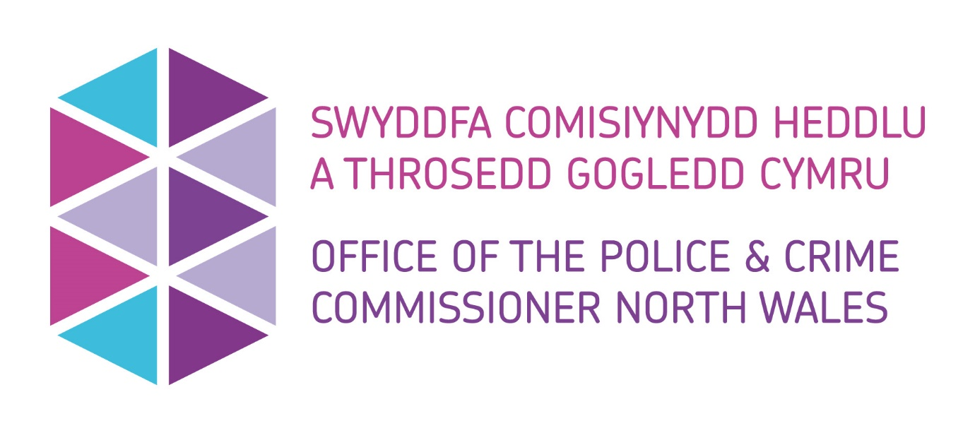

Application for Small Grant Funding
Police and Crime Commissioner for North Wales

Introduction
Police & Crime Commissioners across the UK have the discretion of awarding funding to various groups by exercising of the power conferred by section 143 of the Anti-social Behaviour, Crime and Policing Act 2014.
North Wales Police & Crime Commissioner has the authority to exercise this power to support his Police and Crime Plan and ensure the key priorities are met.
North Wales Police & Crime Commissioner has funding available to communities, partners, and charities through various grants and/or donations.

Using this form
Please use this form if you would like to apply for a maximum of £1000 from the Police and Crime Commissioner.
Accessibility
If it is difficult for you to use this form or this service, for example, if English is not your first language or you have a disability, then please contact us using the details provided below:
Telephone: 01492 805486
Email: Commissioning@northwales.police.uk
If you require any adjustments to support you to complete this application form, please let us know. For example, if you have a visual impairment, you may require written responses in larger text.

What happens to the information in the application form?
The information you provide will be entered into our systems.
If you require further information about how your data will be handled, please call us on 01492 805486.
For information about how we handle your personal information, please read our privacy policy at:
Privacy Policy | Office of the Police and Crime Commissioner North Wales (northwales-pcc.gov.uk)

Where to send this form:
Please submit your completed form to the Office of the Police and Crime Commissioner (OPCC), as below:
Email: Commissioning@northwales.police.uk
Address: Office of the Police and Crime Commissioner for North Wales, North Wales Police Headquarters, Abergele Road, Glan- Y – Don, Conwy, LL29 8AW

Section 1 – Applicant Information

^{1.1 Applicant Details}
- Applicant Name(s)
- Applicant(s) position in organisation
- Applicant Email address
- Applicant(s) Contact Number(s)
- Preferred contact method

^{1.2 Organisation Details}
- Organisation Name
- Organisation Address

1.3 Organisational Structure
- Organisation Type
(i.e. Community Group, Charity, Educational Establishment, Public Body, Social Enterprise etc)
- Company or Charity Number
(If applicable)

Section 2 – Project Detail

2.1 Summary Information
- Project Title
- Project Overview

- Project start date
- Project end date
- Project location(s)
(Specify towns/communities)

2.2 Welsh Language Provision
- If relevant for this application, can you please confirm that the project activity can embrace the Welsh Language? Welsh Language | Office of the Police and Crime Commissioner North Wales (northwales-pcc.gov.uk)

☐ Yes
☐ No
☐ Maybe
☐ Not Relevant

(Further discussion may be required to understand the barriers)

- Detail how you will support and promote the Welsh Language?
(Max 300 words)
- If you have ticked ‘No’, ‘Maybe’ or ‘Not Relevant’ please explain.
(Max 300 words)

2.3 Funding Requested
Total amount of funding requested |  | £
Funding period |  | Funding Requested (£)
Activity breakdown

Section 3– Declaration

3.1 Applicant Signature
- Signature:

- Name:

- Date:

3.2 Senior Officer Approval
I ‘Name’, ‘Role’ of ‘Organisation’ confirm that the details provided within this application are correct at the time of application.
- Name
- Date

OPCC Internal use only
3.3 Panel Feedback / Recommendation
- Is the project supported by the panel?
- Panel feedback including restrictions or additional requirements
- Any additional Comments

